ASSIGNMENT 1. BN/23A/1859 OLAITAN RHODA

QUESTION1: explain SQL and its uses?

ANS; SQL is an acronym which stands for “STRUCTURED QUERY LANGUAGE”. Which allows users to manage and manipulate database. Both database and SQL are interrelated. SQL communicate with database system to retirve and manage data and information.

USES OF SQL,

1. SQL is used to manage and retrieve data from database.
2. SQL helps to handle a high-volume data easily.
3. SQL allows you to perfume operations like, ‘insert’, ‘update’, ‘modify’, and ‘delete’ in the database.
4. SQL is used for data extraction and data modification.
5. SQL is used for data management and data-centric analysis.

QUESTION2: what is DBMS.

DBMS is an acronym which means ‘DATABASE MANAGEMENT SYSTEM’. DBMS is a software used to store data and manage database. Management system interact with database to extract and modify data. Examples of DBMS are; MySQL, Oracle etc. DBMS is effective in storing and managing data, efficient in handling high volume of data. The data, hardware(computer), software (MySQL), user access and procedure (instructions use to command the database) all make up the components of DBMS

QUESTION3: Show how to create database, and table in sql

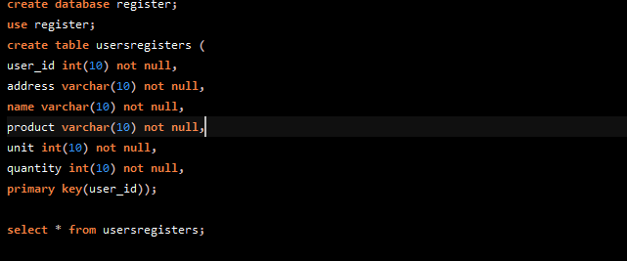

QUESTION4; enter 10 records in the table.

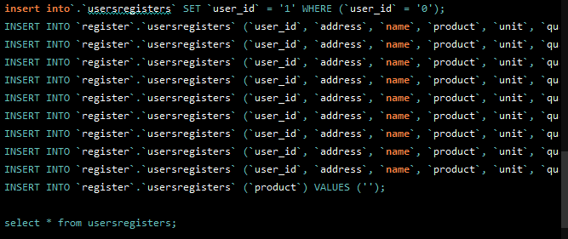

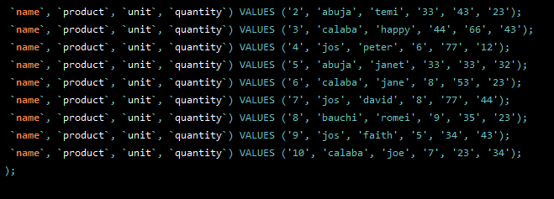

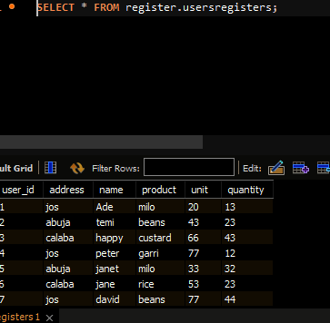

QUESTION5a: explain the following fuctions; Sum(), Avg(), Min(), Max().

1. Sum(); is used to get the total of all values through a specific conditional statement.
2. Avg(); This function return the average value of a numeric column.
3. Min(); This function return the lowest value of a numeric column.
4. Max(); This functiom return the highest value of a numeric column.

QUESTION5b.

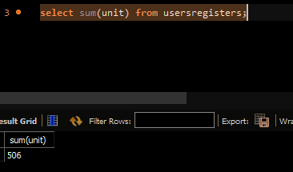

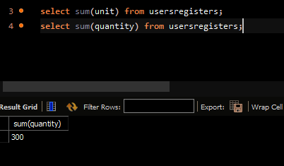

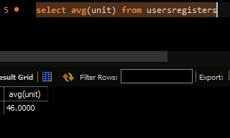

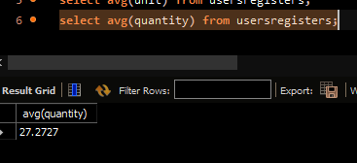

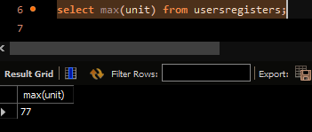

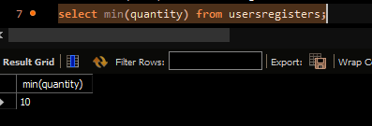

QUESTION6; SQL QUERY to show todays date.

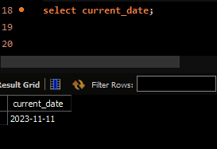

QUESTION7; SQL QUERY on sales track

QUESTION8: Explain the following date functions, NOW(), DATE_ADD(), DATE_SUB(), DATEDIFF().

1. NOW(); This function returns the current date and time. Which is returned as ‘YYYY-MM-DD-HH-MM-SS.
2. DATE_ADD(); This function adds a whole number increment to a specific date value and return the date.
3. DATE_SUB(); This function subtract a time/date interval from a date.
4. DATEDIFF(); This function compares two dates and return the difference.

QUESTION 9: Explain BETWEEN and its use-case in SQL.

The SQL ‘BETWEEN’ operator/conditon is used to test whether an expression is within a range of values. This operator includes the state and end values of the range. Use-case. ‘ select between 1000,2000’.